Code Sample - 

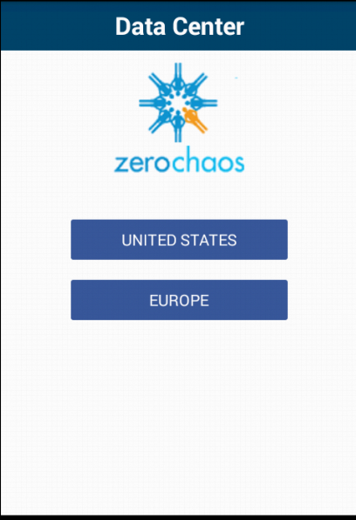

Screen 1

Click “United States”

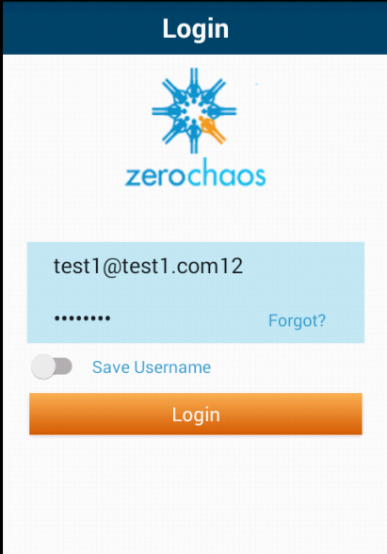

Screen 2

Click “Login”

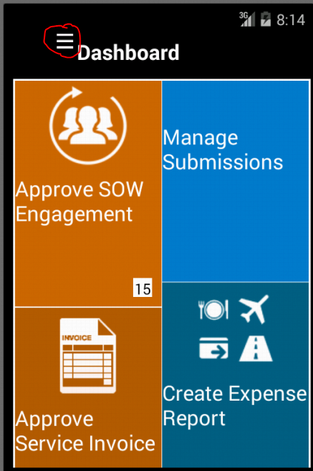

Screen 3

Click the circled ellipses.

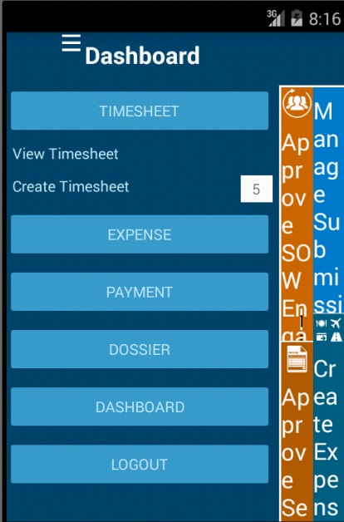

Screen 4

Click View Timesheet

This brings up a list of timesheets that can be viewed and navigated.

**Questions:**

1. How does code organization look like?
2. Options around incorporating Progress indicator.
3. Detail page is shrunk when left navigation bar is open. Existing behavior is the detail page should float to left.

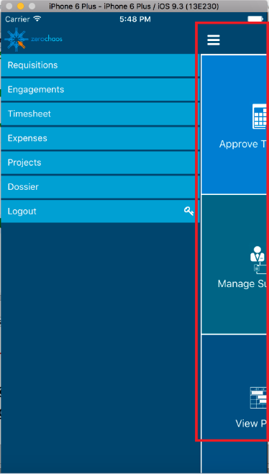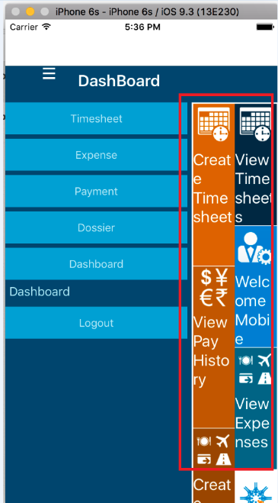

Titanium

Xamarin

1. Sidebar button and heading are not moving in line with detail page.

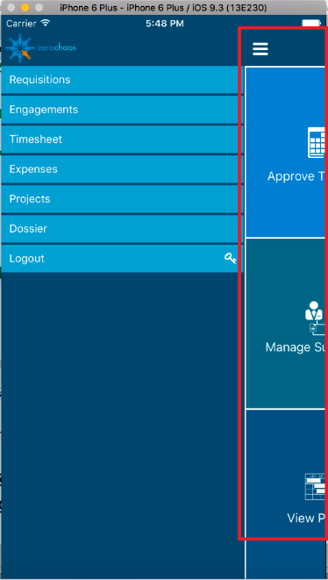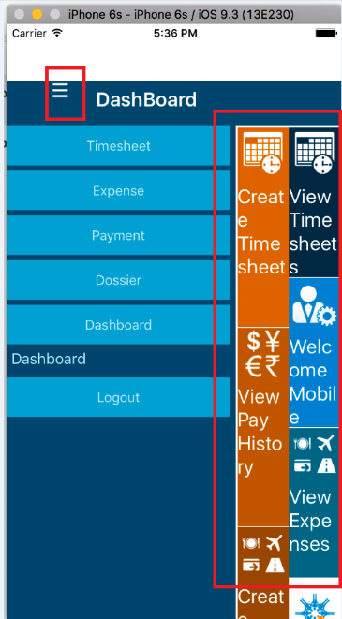

Titanium

Xamarin

1. Activity indicator on login page is not appearing proper.

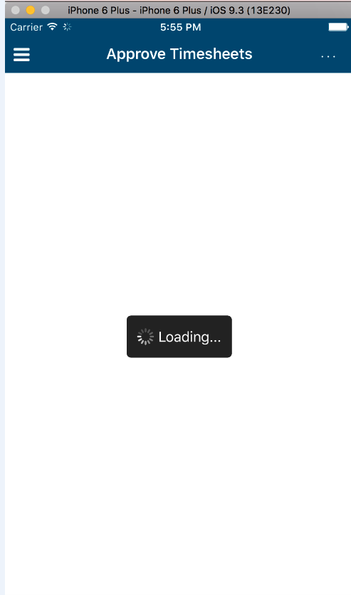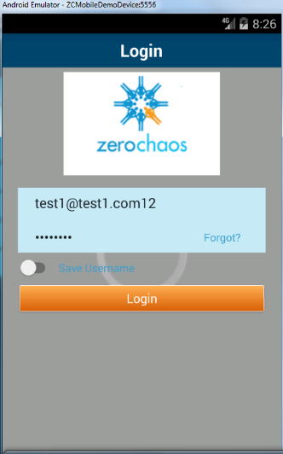

Titanium

Xamarin

1. Need help on download attachment functionality.
2. What is the equivalent of ContentControl of WPF in Xamarin.Forms. If contentview is one option then how can content property be binded through viewmodel. (How can we achieve 2way binding)
3. How to update list page (view) when any action is performed on detail page (view). E.g timesheet is approved on detail page to be reflected on list page without making service call.
4. Better way to maintain navigation stack in the POC we did. We have created a base view model and that contains a property of MasterDetailViewModel type that we are maintaining across the pages. When opening a new View, this property is initialized for that view in view model. Need better approach on this.

